**SCIN130: Introduction to Biology with Lab - The Outline**

Student Name and Section Number

Assignment 2 Outline: Rheumatoid Arthritis

1. **Introduction**
   1. Reason for selecting topic
      1. It is a common problem that affects a large number of people and their wellbeing
      2. I have witnessed it first hand through some of my elderly relatives
      3. There is a need to create awareness of the condition and best strategies to deal with it
   2. Definition of Rheumatoid Arthritis (RA)
      1. Rheumatoid Arthritis is an autoimmune and inflammatory disease
      2. Body immune system attacks healthy cells (National Health Services, 2022)
      3. It mostly affects the joints beginning with the lining of the joints
   3. History of RA
      1. Likely to have been identified 300s B.C.by Hippocrates
      2. In AD 123 Indian medical tests show abnormalities similar to RA
      3. First studies in 1800s
      4. RA distinguished from other arthritis 1859 (Deane & Holers, 2019)
      5. American College of Rheumatology formed 1934
      6. RA distinguished as a condition 1940
   4. Image
      1. An elderly woman with hand joints deformed due to rheumatoid arthritis

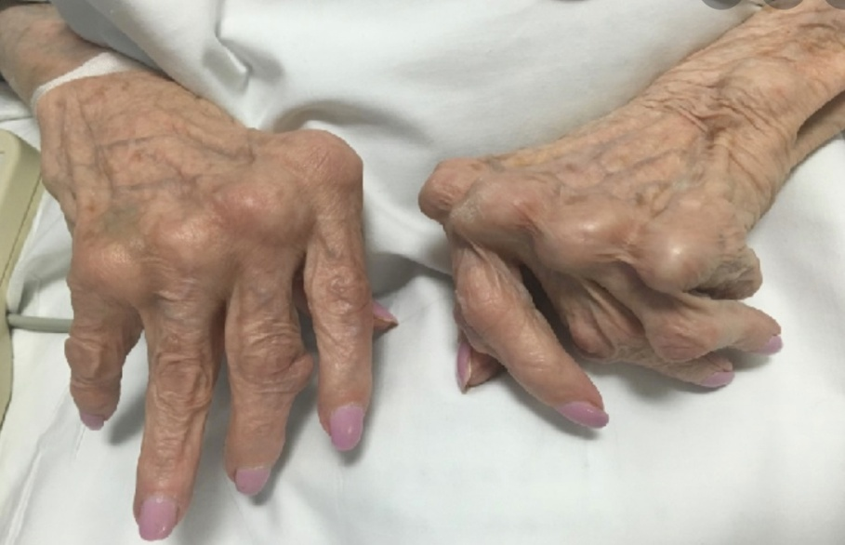

(Image credit: [My Emerald Health](https://www.google.com/url?sa=i&url=https%3A%2F%2Fmyemeraldhealth.com%2Fworstfoods-for-rheumatoid-arthritis%2F&psig=AOvVaw28uzOBG0p-fz04D-bzbDrQ&ust=1671087539760000&source=images&cd=vfe&ved=0CBIQ3YkBahcKEwjoh8OsxPj7AhUAAAAAHQAAAAAQEg))

1. **Content Section**
   1. **Statistics and Epidemiology**
      1. RA I the most common form of autoimmune arthritis (American College of Rheumatology)
      2. Global prevalence of RA is between 0.5% to 1% of the population in developed countries (England & Mikuls, 2020)
      3. In developing countries such as those in Africa and Middle East, it ranges between 0.06% and 3.4%.
      4. More than 1.3 million people in the USA have RA
      5. It represents almost 1% of the whole population
      6. RA is more common in women than in men
      7. It can lead to a range of poor long term outcomes which are however reduced with the use of aggressive treatment strategies
      8. RA is ore prevalent in some populations more than others e.g. Pima Native Americans have a 10 times higher rate of getting the disease than most other populations (Helget et al., 2021)
   2. **Costs**
      1. Direct costs
         1. Medication costs- DMARDs costs the patients between $1,500 and $2000 each year depending on the prescribed medication
         2. Biologics as a new type of RA treatment costs patients between $1,300 and $3000 per month
         3. Surgery in addition to medication is also expensive. For instance knee replacements could cost over $30, 249
         4. Payments for assistive devices, physical therapy after surgeries are additional cost burdens to patients and their families
         5. Annual direct costs for rheumatoid arthritis (RA) patients are estimated to range from $12,509-$36,053
      2. Indirect cots
         1. Osteoarthritis and rheumatoid arthritis costs the National Health Service Money is lost when a patient productivity is reduced
         2. Lost wages, absenteeism can cost between $1,500 and $22,000 a year per patient
         3. Increases the costs of Medicare as RA patients pay more than those without the condition
         4. As of 2013 the total cost of arthritis attributed conditions cost the government $303.5 billion due to medical costs and lost earnings (Center for Disease Control and Prevention, 2020)
         5. The figure as of today could have ballooned to double due to increasing costs of care and prevalence of the disease
   3. **Anatomy & Physiology and Etiology**
      1. Involves the breakdown of structures of the joint, particularly cartilage
      2. Characterized by the presence of autoantibodies known as rheumatoid factors (RF) and anti-citrullinated peptide antibodies
      3. Leads to pain stiffness, and joint deformities
      4. Causes of the diseases yet to be known
      5. Combination of hormonal, genetic and environmental factors are likely attributed to the disease
   4. **Diagnosis/Treatment/Prognosis**
      1. Diagnosis of RA
         1. There are no blood tests or physical findings that can con firm the diagnosis in early stages
         2. ESR and CRP levels also used to test rheumatoid arthritis that help to indicate inflammatory processes in the body
         3. X-rays help track the progression of the disease. MRI and ultrasounds can help judge severity of disease
      2. Treatment of RA
         1. Medications
            1. Nonsteroidal anti-inflammatory drugs (NSAIDs) can relieve pain and reduce inflammation.
            2. Steroids**-**Corticosteroid medications, such as prednisone, reduce inflammation
            3. Conventional DMARDs-These drugs can slow the progression of RA
            4. Targeted synthetic DMARDs such asBaricitinib (Olumiant), and tofacitinib used after others fail
            5. The use of biological agents also known as biological response modifiers
         2. Therapy
            1. Doctor may refer one to a physician or occupational therapists
            2. Doctor refer to assistive devices
         3. Surgery
            1. Synovectomy -Surgery to remove the inflamed lining of the joint
            2. Surgeon may be able to repair the tendons around your joint
            3. Joint fusion to stabilize or realign joint to relief pain
            4. Total joint replacement-damaged parts are removed and a prosthesis inserted
      3. Prognosis of RA
         1. RA causes 80% to 85% joint damage in patients
         2. Most damage occurs after 2 years of the disease
         3. Mortality risk increases when disease is untreated
         4. Individuals with untreated RA are twice likely to die compared to those that do not have the condition
         5. RA reduces life expectancy by as much as 10 to 15 years
2. **Conclusion**
   1. Rheumatoid Arthritis is an autoimmune and inflammatory disease where the body immune system attacks healthy cells
   2. First studies on RA were as early as the 1800s with it being distinguished from other arthritis in 1940s
   3. It causes deformity in the joints of a patient
   4. Annual direct costs for rheumatoid arthritis (RA) patients are estimated to range from $12,509-$36,053
   5. The condition is diagnosed through physical examination and x-rays and treatment include the use of medication, therapy or surgery
   6. Lack of treatment leads to increased mortality reducing life expectancy by over 10 years

**References**

Centers for Disease Control and Prevention. (2020, March 2). *Cost statistics: The Cost of Arthritis in US Adults*. <https://www.cdc.gov/arthritis/data_statistics/cost.htm>

Deane, K. D., & Holers, V. M. (2019). The natural history of rheumatoid arthritis. *Clinical therapeutics*, *41*(7), 1256-1269. <https://doi.org/10.1016/j.clinthera.2019.04.028>

England, B. R., & Mikuls, T. R. (2020). Epidemiology of, risk factors for, and possible causes of rheumatoid arthritis. *URL:* <https://www.uptodate.com/contents/epidemiology-of-risk-factors-for-and-possible-causes-of-rheumatoid-arthritis>

Helget, L. N., England, B. R., Roul, P., Sayles, H., Petro, A. D., Michaud, K., & Mikuls, T. R. (2021). Incidence, prevalence, and burden of gout in the Veterans Health Administration. *Arthritis care & research*, *73*(9), 1363-1371. <https://doi.org/10.1002/acr.24339>

National Health Services. (2022). Rheumatoid Arthritis. <https://www.nhs.uk/conditions/rheumatoid-arthritis/>